**09. Hexagonal Grid: Distance**

**Condition:**

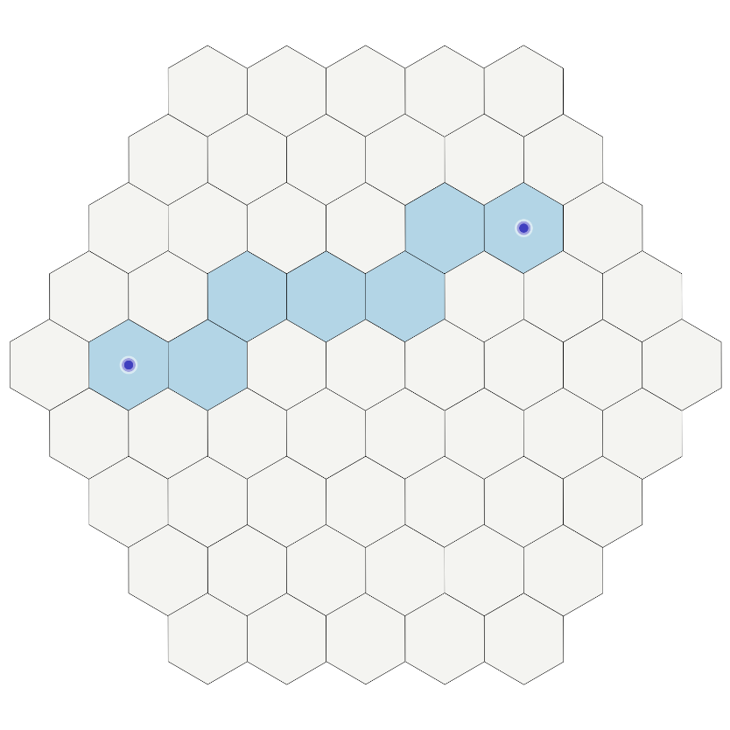A hexagonal grid is a game board made of hexagonal tiles. In the following grid, the two marked locations have a minimum distance of 6, since it takes at least 6 steps to reach the second location starting from the first.

Write a program that takes a hexagonal grid with two marked locations as input and returns the distance between them.

The input grid will be a list of strings where each tile is represented by an 'o' and the two marked locations by an 'x'. The goal is to find the shortest path between the two marked locations. As the grid will always contain exactly two 'x's and will always be correct.

**Input:**

* A hexagonal grid made up of the characters 'o' and 'x'.

**Output:**

* The shortest distance between the two 'x' characters should be output.

**Examples:**

|  |  |
| --- | --- |
| **Input** | **Output** |
| about  oh, oh  ox | 1 |